CONTENTS
SL.NO | particulars | PAGE.NO
1 | Abstract | 2
2 | System Specifications | 3
3 | Introduction to openGL | 4
5 | Implementation | 7
6 | Interaction | 9
7 | Source Code | 10
8 | Output | 27
9 | Conclusion | 29
10 | Bibliography | 30

Abstract

- Main aim of this Mini Project is to illustrate the concepts and usage of Congestion Control in OpenGL.
- In data networking and queuing theory, network congestion occurs when a link or node is carrying so much data that its quality of service deteriorates
- When more packets were sent than could be handled by intermediate routers, the intermediate routers discarded many packets, expecting the end points of the network to retransmit the information.
- When this packet loss occurred, the end points sent extra packets that repeated the information lost, doubling the data rate sent, exactly the opposite of what should be done during congestion.
- This pushed the entire network into a 'congestion collapse' where most packets were lost and the resultant throughput was negligible.
- We have used input devices like mouse and key board to interact with program

System specifications

- SOFTWARE REQUIREMENTS :

- MICROSOFT VISUAL C++
- OPENGL

- HARDWARE REQUIREMENT :

- GRAPHICS SYSTEM,
- Pentium P4 with 256 of Ram(Min)

Introduction to openGL
As a software interface for graphics hardware, OpenGL's main purpose is to render two- and three-dimensional objects into a frame buffer.
These objects are described as sequences of vertices or pixels.
OpenGL performs several processing steps on this data to convert it to pixels to form the final desired image in the frame buffer.

OpenGL Fundamentals
This section explains some of the concepts inherent in OpenGL.

Primitives and Commands
OpenGL draws primitives—points, line segments, or polygons—subject to several selectable modes.
You can control modes independently of each other; that is, setting one mode doesn't affect whether other modes are set .Primitives are specified, modes are set, and other OpenGL operations are described by issuing commands in the form of function calls.
Primitives are defined by a group of one or more vertices. A vertex defines a point, an endpoint of a line, or a corner of a polygon where two edges meet. Data is associated with a vertex, and each vertex and its associated data are processed independently, in order, and in the same way. The type of clipping depends on which primitive the group of vertices represents.
Commands are always processed in the order in which they are received, although there may be an indeterminate delay before a command takes effect. This means that each primitive is drawn completely before any subsequent command takes effect. It also means that state-querying commands return data that's consistent with complete execution of all previously issued OpenGL commands.

Basic OpenGL Operation
The figure shown below gives an abstract, high-level block diagram of how OpenGL processes data. In the diagram, commands enter from the left and proceed through what can be thought of as a processing pipeline. Some commands specify geometric objects to be drawn, and others control how the objects are handled during the various processing stages.
Figure . OpenGL Block Diagram

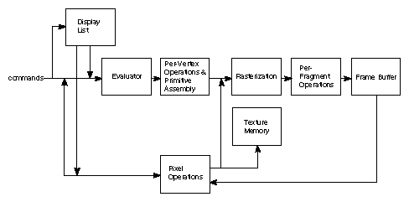

As shown by the first block in the diagram, rather than having all commands proceed immediately through the pipeline, you can choose to accumulate some of them in a display list for processing at a later time.
Rasterization produces a series of frame buffer addresses and associated values using a two-dimensional description of a point, line segment, or polygon.
Each fragment so produced is fed into the last stage,
per-fragment operations, which performs the final operations on the data before it's stored as pixels in the frame buffer. These operations include conditional updates to the frame buffer based on incoming and previously stored z-value s (for z-buffering) and blending of incoming pixel colors with stored colors, as well as masking and other logical operations on pixel values.
All elements of OpenGL state, including the contents of the texture memory and even of the frame buffer, can be obtained by an OpenGL application.

Implementation
This program is implemented using various openGL functions which are
shown below.
Various functions used in this program.
- glutInit() : interaction between the windowing system and OPENGL is initiated

- glutInitDisplayMode() : used when double buffering is required and depth information is required

- glutCreateWindow() : this opens the OPENGL window and displays the title at top of the window

- glutInitWindowSize() : specifies the size of the window

- glutInitWindowPosition() : specifies the position of the window in screen co-ordinates

- glutKeyboardFunc() : handles normal ascii symbols

- glutSpecialFunc() : handles special keyboard keys

- glutReshapeFunc() : sets up the callback function for reshaping the window

- glutIdleFunc() : this handles the processing of the background

- glutDisplayFunc() : this handles redrawing of the window

- glutMainLoop() : this starts the main loop, it never returns

- glViewport() : used to set up the viewport

- glVertex3fv() : used to set up the points or vertices in three dimensions

- glColor3fv() : used to render color to faces

- glFlush() : used to flush the pipeline

- glutPostRedisplay() : used to trigger an automatic redrawal of the object

- glMatrixMode() : used to set up the required mode of the matrix

- glLoadIdentity() : used to load or initialize to the identity matrix

- glTranslatef() : used to translate or move the rotation centre from one point to another in three dimensions

- glRotatef() : used to rotate an object through a specified rotation angle

Interaction with program
- This program includes interaction through keyboard.

- S → Start the Project
- User Right mouse button to get menu and choose option accordingly.
- Q-> Quit

Source Code

#include <windows.h>
#include<string.h>
#include<stdarg.h>
#include<stdio.h>

#include <glut.h>

void *font;
void *currentfont;
static double x=0.0,x1=-3.5,x2=3.5,y1=-1.4,y2=-1.4,x3=-3.5,y3=1.3;
static double move=-60;
static bool goDown=false,goup=false,down=false,congested=false,remote=false;

void setFont(void *font)
{
currentfont=font;
}

void drawstring(float x,float y,float z,char *string)
{
char *c;
glRasterPos3f(x,y,z);

for(c=string;*c!='\0';c++)
{ glColor3f(0.0,1.0,1.0);
glutBitmapCharacter(currentfont,*c);
}
}

void
stroke_output(GLfloat x, GLfloat y, char *format,...)
{
va_list args;
char buffer[200], *p;
va_start(args, format);
vsprintf(buffer, format, args);
va_end(args);
glPushMatrix();
glTranslatef(x, y,2);
glScaled(0.003, 0.005, 0.005);
for (p = buffer; *p; p++)
glutStrokeCharacter(GLUT_STROKE_ROMAN, *p);
glPopMatrix();
}

void cloud(){

//vertical eclipse
glPushMatrix();
glTranslatef(0.0,0.0,0.0);
glScaled(1,3.5,0.1);
glColor3f(1,1,1);
glutSolidSphere(1,100,100);
glPopMatrix();

//horizotal eclipse
glPushMatrix();
glTranslatef(0.0,0.0,0.0);
glScaled(3,2.65,0.1);
glColor3f(1,1,1);
glutSolidSphere(1,100,100);
glPopMatrix();

glPushMatrix();
glScaled(3.5,1.8,0.1);
glRotatef(60,0.0f,1.0f,1.0f);
glTranslatef(0.0,0.0,0.0);
glColor3f(1,1,1);
glutSolidSphere(1,100,100);
glPopMatrix();

glPushMatrix();
glScaled(1.5,3.5,0.1);
glRotatef(50,0.0f,1.0f,1.0f);
glTranslatef(0.0,0.0,0.0);
glColor3f(1,1,1);
glutSolidSphere(1,100,100);
glPopMatrix();
}

void router(float x6, float y6,float z6)
{

glColor3f(0.2,0.3,1);
glPushMatrix();
glScaled(0.2,1.0,0.1);
glRotatef(91,1.0f,0.0f,0.0f);
glTranslatef(x6,y6,z6);
glutSolidTorus(0.2,1.5,100,100);
glPopMatrix();
}

void dte(float x1, float x2)
{
glPushMatrix();
glTranslatef(x1,x2,0.1);
glScaled(1,0.1,0.1);
glColor3f(1,1,1);
glRotatef(0,0.0f,1.0f,0.0f);
glutWireCube(1.5);
glPopMatrix();
}

void line()
{
glPushMatrix();
glBegin(GL_LINE_LOOP);
glColor3f(1,0,0);
glVertex3f(0.1,-0.2,1);
glVertex3f(0.0,0,1);
glVertex3f(2,1.3,1);
glVertex3f(2.1,1.1,1);
glEnd();
glPopMatrix();
}

void line1()
{
glPushMatrix();
glBegin(GL_LINE_LOOP);
glColor3f(1,0,0);
glVertex3f(0.2,2.5,1);
glVertex3f(0.1,2.3,1);
glVertex3f(2.1,1.1,1);
glVertex3f(2.3,1.2,1);
glEnd();
glPopMatrix();
}

void rack(float x1, float x2)
{
glPushMatrix();
glScaled(0.35,.05,1.0);
glTranslatef(x1,x2,0.1);
glColor3f(0,0,0.3);
glutSolidCube(1.1);
glPopMatrix();
}

void rack1(float x1, float x2)
{
glPushMatrix();
glScaled(1.75,.1,1.0);
glTranslatef(x1,x2,0.3);
glColor3f(0,0,1.3);
glutSolidCube(0.5);
glPopMatrix();
}

void window(float x1, float x2)
{
glPushMatrix();
glScaled(0.5,.3,1.0);
glTranslatef(x1,x2,0.4);
glColor3f(0.1,0.1,0.1);
glutSolidCube(0.5);
glPopMatrix();
}

void top()
{
glBegin(GL_TRIANGLES);

/* Front */
glColor3f(1.0f,1.0f,1.0f);
glVertex3f( 0.0f, 1.0f, 0.0f);
glColor3f(1.0f,1.0f,1.0f);
glVertex3f(-0.5f,-0.5f, 0.5f);
glColor3f(1.0f,1.0f,1.0f);
glVertex3f( 0.5f,-0.5f, 0.5f);

/* Left */
glColor3f(1.0f,1.0f,1.0f);
glVertex3f(0.0f,1.0f,0.0f);
glColor3f(1.0f,1.0f,1.0f);
glVertex3f(-0.5f,-0.5f,0.5f);
glColor3f(1.0f,1.0f,1.0f);
glVertex3f(-0.5f,-0.5,-0.5f);

/* Right */
glColor3f(1.0f,1.0f,1.0f);
glVertex3f(0.0f,1.0f,0.0f);
glColor3f(1.0f,1.0f,1.0f);
glVertex3f(0.5f,-0.5f,0.5f);
glColor3f(1.0f,1.0f,1.0f);
glVertex3f(0.5f,-0.5,-0.5f);

/* Back */
glColor3f(1.0f,1.0f,1.0f);
glVertex3f( 0.0f, 1.0f, 0.0f);
glColor3f(1.0f,1.0f,1.0f);
glVertex3f(-0.5f,-0.5f, -0.5f);
glColor3f(1.0f,1.0f,1.0f);
glVertex3f( 0.5f,-0.5f, -0.5f);
glEnd();
}

void animate();

void network()
{
glClearColor(0.0,0,0,0.0);
//glClear(GL_COLOR_BUFFER_BIT | GL_DEPTH_BUFFER_BIT);
glLoadIdentity();
glTranslatef(0.0f,0.0f,-13.0f);

// glRotatef(ang,1.0f,1.0f,0.0f);

//Server
glPushMatrix();
glScaled(0.8,2.0,0.8);
glTranslatef(5,0.8,0.0);
glColor3f(0,1.5,1.5);
glutSolidCube(1);

glPushMatrix();
glScaled(0.5,.1,1.0);
glTranslatef(.0,3.5,0.01);
glColor3f(0.3,0.3,0.3);
glutSolidCube(1.5);
glPopMatrix();

rack1(.0,1);
rack1(.0,2);
rack1(.0,0);

rack(-1,-4);
rack(1,-4);
rack(-1,-6);
rack(1,-6);
rack(-1,-8);
rack(1,-8);

glPopMatrix();

//Home
glPushMatrix();
glScaled(0.8,1.0,0.8);
glTranslatef(4.8,-2.5,0.0);
glColor3f(1,1,0);
glutSolidCube(1);

glPushMatrix();
glScaled(.7,.1,1.0);
glTranslatef(0.0,4.5,0.2);
glColor3f(1.3,1.3,1.3);
glutSolidCube(1.5);
glPopMatrix();

glPushMatrix();
glScaled(0.12,.3,.75);
glTranslatef(0,-.75,0.02);
glColor3f(0.3,0.3,0.3);
glutSolidCube(1.5);
glPopMatrix();

// Top
glPushMatrix();
glTranslatef(0,.9,0);
top();
glPopMatrix();
window(-.6,-.3);
glPopMatrix();

//Office Building
glPushMatrix();
glScaled(0.8,2.0,0.8);
glTranslatef(-4.8,-1,0.0);
glColor3f(2,.5,.5);
glutSolidCube(1);

window(-.5,1.3);
window(.5,1.3);
window(-.5,0.5);
window(.5,0.5);
window(-.5,-0.3);
window(.5,-0.3);
window(-.5,-1.1);
window(.5,-1.1);

glPopMatrix();

// Remote User

glPushMatrix();
glTranslatef(-4.0,1.5,0.0);
glScaled(0.3,.3,.3);
glColor3f(1.3,1.3,1.3);
glutSolidCube(0.5);
glPopMatrix();

// Routers inside cloud

//router 5
router(10,10,1.15);

//router 2
router(-10,10,-1.3);

//router 1
router(-10,10,1.2);

//router 3
router(0,10,-2.5);

router(0,10,0);

//router 5
router(0,10,2.5);

//router 4
router(10.6,10,-1.2);

// Line 1
glPushMatrix();
glTranslatef(-2.1,0.0,0.5);
glScaled(0.1,1.8,0.1);
glColor3f(1,0,0);
glutWireCube(1.5);
glPopMatrix();

// Link 2
glPushMatrix();
glTranslatef(-2,1.15,0);
line();
glPopMatrix();

// Link 3 to server
glPushMatrix();
glTranslatef(1.2,1.7,0.5);
glRotatef(57,0,0,1);
glScaled(0.15,1.7,0.1);
glColor3f(1,0,0);
glutWireCube(1.5);
glPopMatrix();

// Link 4
glPushMatrix();
glTranslatef(0.85,0.4,0.5);
glRotatef(120,0,0,1);
glScaled(0.2,1.7,0.1);
glColor3f(1,0,0);
glutWireCube(1.5);
glPopMatrix();

// Link 5
glPushMatrix();
glTranslatef(0,-2.6,0);
line();
glPopMatrix();

// Link 6
glPushMatrix();
glTranslatef(-2.2,-3.85,0);
line1();
glPopMatrix();

// Link 7(1step data transfer from ...)
glPushMatrix();
glTranslatef(-1.2,-0.85,0.5);
glRotatef(125,0,0,1);
glScaled(0.15,1.6,0.1);
glColor3f(1,0,0);
glutWireCube(1.5);
glPopMatrix();

// Link 9
glPushMatrix();
glTranslatef(0.0,1.0,0.5);
glScaled(0.1,1.65,0.1);
glColor3f(1,0,0);
glutWireCube(1.5);
glPopMatrix();

//R0 - R6
glPushMatrix();
glTranslatef(0.0,-1.6,0.5);
glScaled(0.1,1.65,0.1);
glColor3f(1,0,0);
glutWireCube(1.5);
glPopMatrix();

//link 10 from home
glPushMatrix();
glTranslatef(1.05,-0.8,0.5);
glRotatef(52,0,0,1);
glScaled(0.15,1.6,0.1);
glColor3f(1,0,0);
glutWireCube(1.5);
glPopMatrix();

// Office Link to Cloud
dte(-3.0,-1.4);

// Home Link to Cloud
dte(3.0,-1.4);

// Server Link to Cloud
dte(3.0,1.1);

//Cloud Call Function
cloud();

glPushMatrix();

//glScaled(1.1,2.0,0.1);
glTranslatef(0.0,0.0,2.0);

setFont(GLUT_BITMAP_TIMES_ROMAN_24);
glColor3f(0,0,0);
drawstring(-0.3,2.5,0.0,"CLOUD");

setFont(GLUT_BITMAP_TIMES_ROMAN_24);
glColor3f(0,0,0);
drawstring(-2.1,-1.4,0.0,"R1");

setFont(GLUT_BITMAP_TIMES_ROMAN_24);
glColor3f(0,0,0);
drawstring(-2.05,0.95,0.0,"R2");

setFont(GLUT_BITMAP_TIMES_ROMAN_24);
glColor3f(0,0,0);
drawstring(0,2,0.0,"R3");

setFont(GLUT_BITMAP_TIMES_ROMAN_24);
glColor3f(0,0,0);
drawstring(-0.1,-0.3,0.0,"R0");

setFont(GLUT_BITMAP_TIMES_ROMAN_24);
glColor3f(0,0,0);
drawstring(1.8,0.8,0.0,"R4");

setFont(GLUT_BITMAP_TIMES_ROMAN_24);
glColor3f(0,0,0);
drawstring(1.8,-1.35,0.0,"R5");

setFont(GLUT_BITMAP_TIMES_ROMAN_24);
glColor3f(0,0,0);
drawstring(0,-2.6,0.0,"R6");

setFont(GLUT_BITMAP_TIMES_ROMAN_24);
glColor3f(1,1,1);
drawstring(3,-2.1,0.0,"HACKER");

setFont(GLUT_BITMAP_TIMES_ROMAN_24);
glColor3f(1.5,1.5,1.5);
drawstring(-3.7,-0.8,0.0,"OFFICE");

setFont(GLUT_BITMAP_TIMES_ROMAN_24);
glColor3f(1.5,1.5,1.5);
drawstring(3,2.3,0.0,"SERVER");

glPopMatrix();

//Transtitions all together

animate();

glFlush();

glutSwapBuffers();

}

void animate(){

// Company to server Using path 1

glPushMatrix();
glTranslatef(x1,y1,0.2);
glScaled(0.1,0.1,0.1);
glColor3f(0,0,1);
glutSolidCube(0.5);
glPopMatrix();

if(remote){

glPushMatrix();
glTranslatef(x3,y3,0.2);
glScaled(0.1,0.1,0.1);
glColor3f(1,0,0.5);
glutSolidCube(0.5);
glPopMatrix();

}

if(congested)
{

glPushMatrix();
glTranslatef(x2,y2,0.2);
glScaled(0.1,0.1,0.1);
glColor3f(4,0,0);
glutSolidCube(0.5);
glPopMatrix();

}

}

void about()
{
glClearColor(0.5,0.5,0.5,0.0);
glClear(GL_COLOR_BUFFER_BIT | GL_DEPTH_BUFFER_BIT);
glLoadIdentity();
glTranslatef(0.0f,0.0f,-13.0f);

setFont(GLUT_BITMAP_TIMES_ROMAN_24);
glColor3f(0,0,0);
drawstring(-4.2,2,0.0,"About Congestion Control");
setFont(GLUT_BITMAP_TIMES_ROMAN_24);

drawstring(-3.5,1.5,0.0,"* Congestion is a situation in Communication Networks in which too many packets");

drawstring(-3.5,1,0.0," are present in a part of the subnet, performance degrades.");

drawstring(-3.5,.5,0.0,"* In data networking network congestion occurs when a link or node ");

drawstring(-3.5,0.0,0.0," is carrying so much data that its quality of service deteriorates.");

drawstring(-3.5,-0.5,0.0,"* Congestion control concerns controlling traffic entry into a ");

drawstring(-3.5,-1,0.0," telecommunications network, so as to avoid congestive collapse by attempting ");

drawstring(-3.5,-1.5,0.0," to avoid oversubscription of any of the processing or link capabilities ");

drawstring(-3.5,-2,0.0," of the intermediate nodes and networks and taking resource reducing steps, ");

drawstring(-3.5,-2.5,0.0," such as reducing the rate of sending packets.");

drawstring(-3.5,-3,0.0,"* It should not be confused with flow control, which prevents the sender from overwhelming the receiver.");

glFlush();
glutSwapBuffers();
}

void s()
{
glClear(GL_COLOR_BUFFER_BIT | GL_DEPTH_BUFFER_BIT);

network();
}

void com_ser(){

// No congestion, take the best path

if(!congested && !remote)
{
if(x1>=-3.5 && y1==-1.4 && x1<=-2)
{
x1+=0.1;
}

if(x1>=-2 && y1>=-1.4 && x1<=2 && y1<=1.8)
{
x1+=0.1;
y1+=0.065;
}

if(x1>=2 && y1>=1 && x1<=3.8)
{
x1+=0.1;
y1=1.1;
}

}

//if Congested only from Hacker A

if(congested && x2>=2 && y2>=1 && !remote)
{
if(x1>=-3.5 && y1==-1.4 && x1<=-2){
x1+=0.1;

}

if(x1>=-2 && y1>=-1.4 && x1<=0 && y1<=0){
x1+=0.1;
y1+=0.07;
}

if(x1>=-0.05 && x1<=0.05 && y1<=0.05 && y1>=-0.05){
x1=0;
y1=0;
}

if(x1==0 && y1>=0 && y1<=2.6){

y1+=0.06;

}

if(x1==0 && y1>=2.5)
goDown=true;

if(goDown && x1>=0 && x1<=2 && y1<=2.6 && y1>=1 ){
x1+=0.1;
y1-=0.06;
}

if(x1>=2 && y1>=1 && x1<=3.8){
x1+=0.1;
y1=1.1;
}
}

// if congested only from Hacker B

if(remote && y3<=1 && !congested)
{
if(x1>=-3.5 && y1==-1.4 && x1<=-2){
x1+=0.1;

}

if(x1>=-2 && x1<=-0.2 && y1<=-1.4 && y1>=-3){
x1+=0.1;
y1-=0.08;
}

if(x1>=-0.3 && x1<=-0.2 && y1<=-2.7 && y1>=-3 && goup==false){
x1=0;
y1=-3;
goup=true;
}

if(goup && y1<=0){
x1=0.0;
y1+=0.1;

}

if(goup && x1>=0 && y1>=0 && x1<=2 && y1<=1.8)
{
x1+=0.1;
y1+=0.055;
}

if(x1>=2 && y1>=1 && x1<=3.8)
{
x1+=0.1;
y1=1.1;
}

}

// if congested from both Hackers

if(remote && y3<=1 && congested)
{
if(x1>=-3.5 && y1==-1.4 && x1<=-2){
x1+=0.1;

}

if(x1>=-2 && x1<=-0.2 && y1<=-1.4 && y1>=-3){
x1+=0.1;
y1-=0.08;
}

if(x1>=-0.3 && x1<=-0.2 && y1<=-2.7 && y1>=-3 && goup==false){
x1=0;
y1=-3;
goup=true;
}

if(goup && y1<=2.6 && goDown==false){
x1=0.0;
y1+=0.1;
}

if(x1==0 && y1>=2.5)
goDown=true;

if(goDown && x1>=0 && x1<=2 && y1<=2.6 && y1>=1 ){
x1+=0.1;
y1-=0.06;
}

if(x1>=2 && y1>=1 && x1<=3.8){
x1+=0.1;
y1=1.1;
}

}

//congest the server link1, From hacker A to R

if(congested){

if(x2<=3.5 && y2==-1.4 && x2>=1.8)
{
x2-=0.1;
}

if(x2<1.8 && x2>=0 && y2<=0 && y2>=-1.4 )
{
x2-=0.1;
y2+=0.08;
}

if(x2>=-0.05 && x2<=0.051 && y2<=0.051 && y2>=-0.051){
x2=0;
y2=0;
}

if(x2>=0 && y2>=0 && x2<=2 && y2<=1.8){
x2+=0.1;
y2+=0.06;
}

}

// Congest from Hacker B to Company

if(remote)
{
if(x3>=-3.5 && y3==1.3 && x3<=-2)
{
x3+=0.1;
}

if(x3>=-2 && y3<=1.3 && x3<=1.5 && y3>=-1.5 && !down)
{
x3+=0.1;
y3-=0.065;

}
if(x3>=0.0 && y3<=0.0){
x3=0;y3=0;down=true;
}

if(x3<=0 && x3>=-2 && y3>=-1.4 && down)
{
x3-=0.1;
y3-=0.065;
}

}

network();

}

void doInit()
{

/* Background and foreground color */
glClearColor(0.0,0.0,0.0,0);
glViewport(0,0,640,480);

/* Select the projection matrix and reset it then
setup our view perspective */

glMatrixMode(GL_PROJECTION);
glLoadIdentity();
gluPerspective(30.0f,(GLfloat)640/(GLfloat)480,0.1f,200.0f);

/* Select the modelview matrix, which we alter with rotatef() */
glMatrixMode(GL_MODELVIEW);
glLoadIdentity();
glClearDepth(2.0f);
glEnable(GL_DEPTH_TEST);
glDepthFunc(GL_LEQUAL);
}

void display()
{
glClearColor(0.0,0.,0.,0.0);
glClear(GL_COLOR_BUFFER_BIT | GL_DEPTH_BUFFER_BIT);
glLoadIdentity();

glTranslatef(0.0f,0.0f,-13.0f);

setFont(GLUT_BITMAP_TIMES_ROMAN_24);
glColor3f(3.0,1.0,1.0);
drawstring(-1.7,3.0,0.0,"DEPARTMENT OF COMPUTER SCIENCE");
setFont(GLUT_BITMAP_TIMES_ROMAN_24);
glColor3f(0.0,1.0,1.0);
drawstring(-3.0,2.5,0.0,"Computer Graphics Mini Project on CONGESTION CONTROL");
setFont(GLUT_BITMAP_TIMES_ROMAN_24);
glColor3f(0.0,1.0,1.0);
drawstring(-1,2,0,"Using OPENGL");
setFont(GLUT_BITMAP_TIMES_ROMAN_24);
glColor3f(0.0,1.0,1.0);
drawstring(-0.5,1.5,0,"By");

setFont(GLUT_BITMAP_TIMES_ROMAN_24);
glColor3f(0.0,1.0,1.0);
drawstring(-2,1,0,"SUMAYYA TABASSUM (USN : 3KB10CS082)");

setFont(GLUT_BITMAP_TIMES_ROMAN_24);
glColor3f(0.0,1.0,1.0);
drawstring(-2,.5,0,"SUMAYYA SAMREEN (USN : 3KB10CS083)");

drawstring(-2,-0.5,0,"Press --> s to Start");
drawstring(-2,-1,0,"Press --> q to Quit");

GLfloat mat_ambient[]={0.0f,1.0f,2.0f,1.0f};
GLfloat mat_diffuse[]={0.0f,1.5f,.5f,1.0f};
GLfloat mat_specular[]={5.0f,1.0f,1.0f,1.0f};
GLfloat mat_shininess[]={50.0f};

glMaterialfv(GL_FRONT,GL_AMBIENT,mat_ambient);
glMaterialfv(GL_FRONT,GL_DIFFUSE,mat_diffuse);
glMaterialfv(GL_FRONT,GL_SPECULAR,mat_specular);
glMaterialfv(GL_FRONT,GL_SHININESS,mat_shininess);

GLfloat lightIntensity[]={1.7f,1.7f,1.7f,1.0f};
GLfloat light_position3[]={0.0f,5.0f,5.0f,0.0f};

glLightfv(GL_LIGHT0,GL_POSITION,light_position3);
glLightfv(GL_LIGHT0,GL_DIFFUSE,lightIntensity);

glEnable(GL_COLOR_MATERIAL);

glFlush();
glutSwapBuffers();

}

void menu(int id)
{
switch(id)
{
case 1:
glClear(GL_COLOR_BUFFER_BIT | GL_DEPTH_BUFFER_BIT);
glutIdleFunc(s);
break;

case 2:
glClear(GL_COLOR_BUFFER_BIT | GL_DEPTH_BUFFER_BIT);
goDown=false;
goup=false;
x=0.0;x1=-3.5;y1=-1.4;
x2=3.5;
y2=-1.4;
glutIdleFunc(com_ser);
break;

case 3:
glClear(GL_COLOR_BUFFER_BIT | GL_DEPTH_BUFFER_BIT);
goDown=false;
down=false;
goup=false;
x=0.0;x1=-3.5;y1=-1.4;
x2=3.5;
y2=-1.4;
x3=-3.5,y3=1.3;
congested=true;
glutIdleFunc(com_ser);
break;

case 4:
glClear(GL_COLOR_BUFFER_BIT | GL_DEPTH_BUFFER_BIT);
goDown=false;
down=false;
goup=false;
x=0.0;x1=-3.5;
x2=3.5;
y1=-1.4;
y2=-1.4;
x3=-3.5;y3=1.3;
remote=true;
glutIdleFunc(com_ser);
break;

case 5: congested=false;
goDown=false;down=false;
goup=false;
x=0.0;x1=-3.5;
x2=3.5;
y1=-1.4;
y2=-1.4;
x3=-3.5;y3=1.3;
glutIdleFunc(com_ser);
break;

case 6: remote=false;
down=false;
goDown=false;
goup=false;
x=0.0;x1=-3.5;
x2=3.5;
y1=-1.4;
y2=-1.4;
x3=-3.5;y3=1.3;
glutIdleFunc(com_ser);
break;

case 7:
glClear(GL_COLOR_BUFFER_BIT | GL_DEPTH_BUFFER_BIT);
glutIdleFunc(about);
break;

case 8:exit(0);
break;

}
glFlush();
glutSwapBuffers();
glutPostRedisplay();
}

void mykey(unsigned char key,int x,int y)
{

if(key=='s')
{
glutIdleFunc(s);
}

if(key=='q'||key=='Q')
{
exit(0);
}

}

void main(int argc, char *argv[])
{
glutInit(&argc, argv);
glutInitDisplayMode(GLUT_DOUBLE|GLUT_RGB);
glutInitWindowSize(1000,480);
glutInitWindowPosition(0,0);
glutCreateWindow("Local Area Network");
glutDisplayFunc(display);

glEnable(GL_LIGHTING);
glEnable(GL_LIGHT0);
glShadeModel(GL_SMOOTH);
glEnable(GL_DEPTH_TEST);
glEnable(GL_NORMALIZE);

glutKeyboardFunc(mykey);

glutCreateMenu(menu);

glutAddMenuEntry("Send Some Data",2);
glutAddMenuEntry("Create Congestion From Hacker A",3);
glutAddMenuEntry("Create Congestion From Hacker B",4);
glutAddMenuEntry("Remove Congestion From Hacker A ",5);
glutAddMenuEntry("Remove Congestion From Hacker B ",6);
glutAddMenuEntry("About Project 'a/A'",7);
glutAddMenuEntry("Quit 'q'",8);
glutAttachMenu(GLUT_RIGHT_BUTTON);
doInit();

glutMainLoop();

}
OUTPUT OF THE PROGRAM

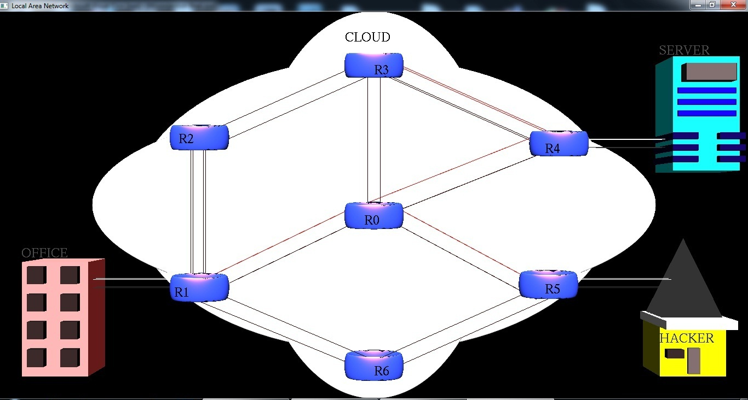

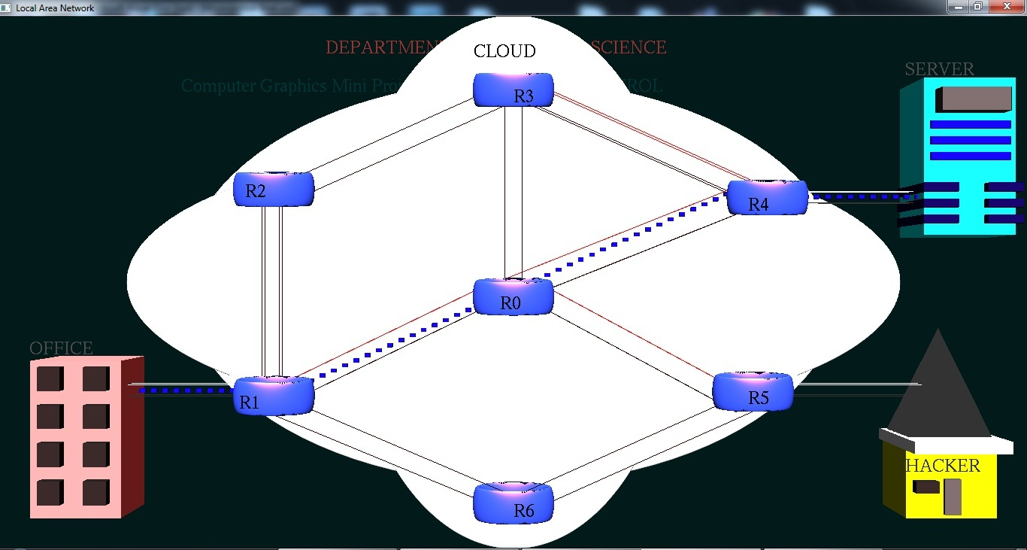
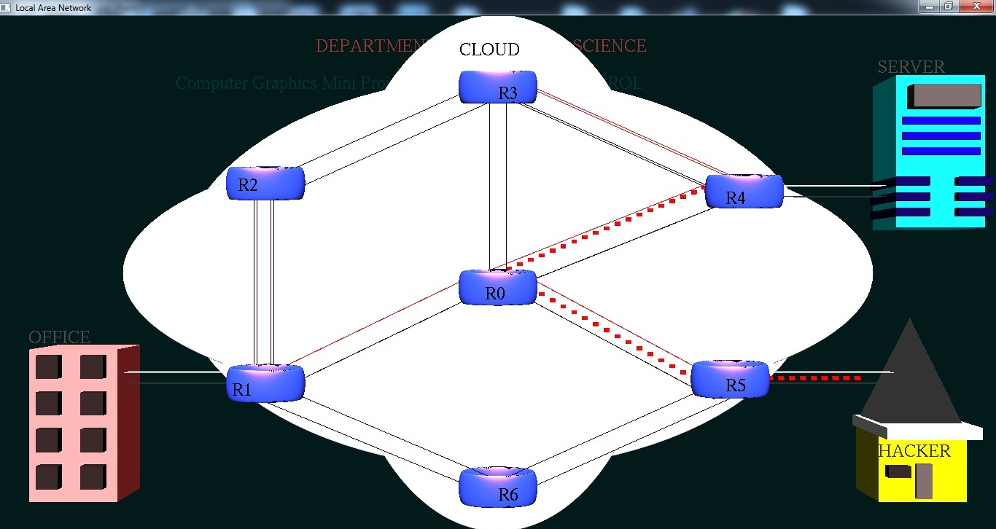
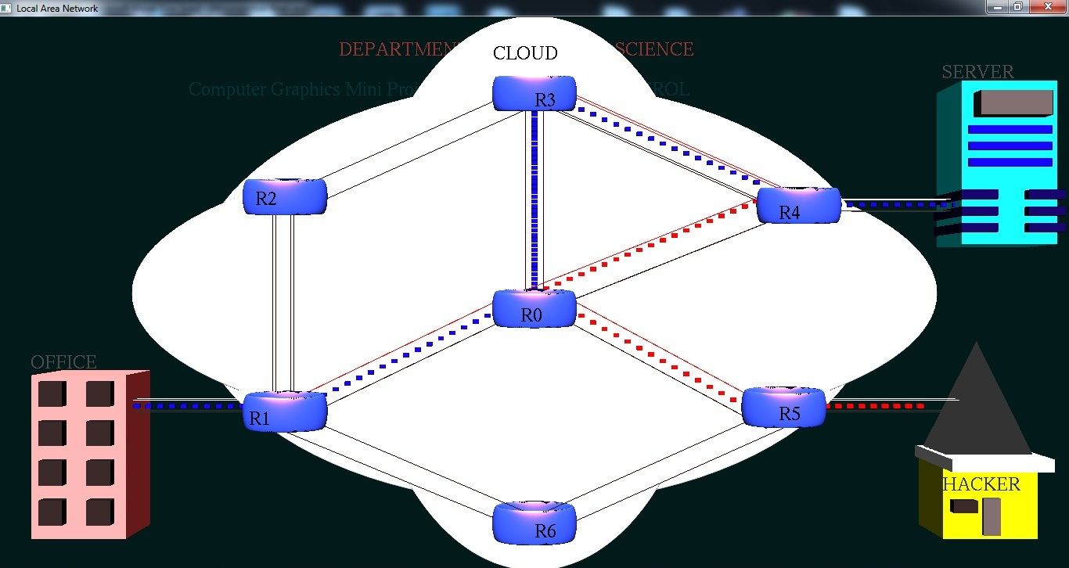

Conclusions

The project “Electro Magnet” clearly demonstrates the Faraday’s law of electromagnetic induction.
Finally we conclude that this program clearly illustrate the Electromagnetic induction using openGL and has been completed successfully and is ready to be demonstrated.

Bibliography
WE HAVE OBTAINED INFORMATION FROM MANY RESOURCES TO DESIGN AND IMPLEMENT OUR PROJECT SUCCESSIVELY. WE HAVE ACQUIRED MOST OF THE KNOWLEDGE FROM RELATED WEBSITES. THE FOLLOWING ARE SOME OF THE RESOURCES :

- TEXT BOOKS :
INTERACTIVE COMPUTER GRAPHICS A TOP-DOWN APPROACH
-By Edward Angel.

- COMPUTER GRAPHICS,PRINCIPLES & PRACTICES
- Foley van dam
- Feiner hughes

- WEB REFERENCES: http://jerome.jouvie.free.fr/OpenGl/Lessons/Lesson3.php
http://google.com
http://opengl.org

